Slope construction
Name
Institutional Affiliation
Date

Abstract
Slope construction, with its many advantages has been an attractive concept as early as man understood the aspect of infrastructure. Constructing on a slope can be an uphill task even for seasoned engineers. It brings along a set of challenges that are not experienced in the typical flat construction sites. It takes keen and calculated attention on the structures involved to ensure stability of both the real estate and public infrastructure and that of the land, the slope terrain. To avoid accidents, tools, machines and software have been developed to aid engineers. Plaxis is one such software aiding in the analysis and design in slope construction.

Key words; Slope construction, stability, Plaxis, Research and Development, Analysis and Design.

Introduction
Construction on slopes has provided mankind with numerous benefits becoming more and more attractive for settlement and infrastructure with time. Such construction as witnessed on many a hill, valley and mountain slopes include mansions, resorts, rods, security walls, towers, apartments, art designs, sculptures, corporate and headquarter offices, dams and homesteads varying complex luxurious houses to simple cabins. Construction on slopes offers any benefit including but not limited prevailing slope breezes and amazing mountain side or hill side views, suitable fortress site and privacy. These benefits also come bearing challenges that sees to it that many commercial areas are not located on sloppy terrains. Slope terrains creates a complexity that is difficult to overcome in construction. Since the sites are located in unique areas, there is a need for specialized equipment to effectively function in the limited construction space. The cost of construction in such terrain is quite high. In many cases these terrain require a larger budget to cover the need to build up land or flatten the slope or when it requires enhanced drainage and sewage accessibility for the street at the ground levels.
Despite the challenges, amazing construction projects have been developed on slopping construction cites. Numerous designs have been developed to suit the degrees of slopes and the terrain structure. Embankments n foundations are also customized to the individual structure of the land on construction sites. However with increasing slope construction, so has accidents and casualties resulting from the same increased. Some of the risks that are faced on slope construction include liquefaction, excessive deformation, piping, surface sloughing and shear failure of slope and any other slope movements. In such light tools, machines and programs have been developed to help avert sh tragedies. Plaxis is one such software that helps in analysis of the stability of construction site on a slope and also in designing the slope and the construction project. It is important therefor that one understands the essence of such software in helping the slope construction.
Slope construction and Maintenance practices.
In the concurrent times, it has become common to see construction undertaken in considerable heights and large base areas on mountain and sloppy terrains especially for cities located in hilly and mountainous regions (Wahid, 2007). In historic to modern times, constructions have been brought up in the slopes of hills for various reasons. Roads, dams, corporate buildings, luxurious resorts and homesteads are located on relatively sloppy to very steep slopes on mountains and hilly ranges. Building on sloping sites offers many advantages. These advantages vary dependent on the construction sites. They include the opportunity to capture the prevailing slope breezes and amazing mountain side or hill side views. They also give leverage over attacks and make a suitable fortress site (Wahid, 2007). They provide privacy many a times as slope constructions tend to be spars and spread out due to the difficult terrains for construction.
Many owners of constructions on hillsides or steep mountainous slopes are captivated by the breathtaking views that these cites overlook. They are located on an elevated positons over cites and beautiful valleys, or mountain ranges and lakes and sea shores. In comparison to flat lots of constructions, the sloppy lots provide a greater privacy dependent on the terrain. The construction on the slopes allows for unique and creative designing to fit the challenges that constructions on slopes present to architects and engineers (Wahid, 2007). These designs vary from landscaping to interior scope to exterior view. Expert assistance on the slope can help come up with an efficient designs customized to the setting of the environment and sloppy terrain and the desires of the owners of the construction project varying from Frank Lloyd Wright inspired constructions to Asian contemporary construction design (Wahid, 2007).
The sloppy strain also provides adequate spacing. With steep slopes there is added basement space having much more natural light due to terrain inclination exposing the contrition side on the lower slope to more light (Wahid, 2007). Unlike basements that are fully underground in flat construction cites, the slope construction basements can have full length windows and walk out capabilities. This has become a re more preferred construction design in the recent years.
The Engineering and design manual–slope.
The Engineering and design manual–slope stability by Army corps department of America sets some light on the challenges and risk of failure that can be faced on slope constructions. The annual exerts that here have been numerous reports of slope related failure sin the field of construction (Engineers U. A. C. O., 1902). These failures cost a lot of money and more over they cost lives. To date, the field of construction has experienced failures that have and covered by the media scarcely and sooner or later forgotten. More often than not do such failure receive the attention deserving, where inquiries on basis of their construction and design (Engineers U. A. C. O., 1902). Engineering and design manual–slope stability elaborates some of the risks that are faced on slope construction including liquefaction, excessive deformation, piping, surface sloughing and shear failure of slope and any other slope movements (Engineers U. A. C. O., 1902).
Liquefaction
This term, soil liquefaction, describes the significant reduction of the soil strength. It also describes the stiffness that results from the shear-induced pressure increase of pore water. It is the major case of damage resulting for earthquake and tremors on slopes and embankments (Engineers U. A. C. O., 1902). Silty soil or saturated soil loosely attached to the ground is more often than not related to the instances of liquefaction. Slopes hat have loose gravelly soil are also subject to liquefaction. Slopes that are composed of cohesive solid with a PI (plasticity index) of more than 14 or more than 20% of particles having fineness of more than 0.005 are considered to be relatively safe from liquefaction (Engineers U. A. C. O., 1902).
Piping
In conjunction to erosion, piping occurs when hydraulic gradients that are found downstream, at the end of a hydraulic system on a slope are large enough to move the soil particle causing movement on the slope. These movement structurally alter the base of the construction and therefore imposing a threat of collapse (Engineers U. A. C. O., 1902).
Excessive deformation
While cohesive soils are considerably safe, large strains may develop into peak shear resistance that result to the soils deforming excessively when loaded. Special attention should be employed on the stress strain response of the se cohesive soil slopes embankments and foundation during their design to avoid excessive deformation. In the event that the strains required to put into mobilize the peak strengths are larger than 15%, then deformation may be excessive on the slope construction embankments or foundations. Such cases therefore necessitate the utility of shear resistance that is mobilized at 10%-15% of the strain instead of peak strengths (Engineers U. A. C. O., 1902). Limiting the placement water contents on the dry side of optimum will also help in the reduction of the magnitude of excessive deformation. Cracks on the slope can have negative effects on the seepage and ultimately the stability of the construction on the slope (Engineers U. A. C. O., 1902). If cohesive soils are too dry they may become wet later on under load of the construction ensuring to excessive settlement.
Shear failure
This term describes the event when a portion of an embankment slides off the slope or an embankment and the whole foundation. Shear failure happens along the discrete surface of the slope and across the zone of the appreciable thickness. The failure surfaces of the sloppy areas frequently approximately circular in shape (Engineers U. A. C. O., 1902). Thin foundation layers on the slopes or zoned embankments that overlay the bedrock or when there exists a weak strata within a deposit the failure surface failure will be composed of plane and interconnected arcs.
Surface sloughing
It is the shear failure that happens when the surface portion of the slope embankment moves downwards and is called the surface slough. Since it does not affect the structural stability of the slope embankment it is considered to be a maintenance problem. Repair or the surface slough can however bring about a considerable cost in the construction project. If they are not repaired they may become larger posing a threat to the stability of the embankment and the foundation of the construction project (Engineers U. A. C. O., 1902).
Geotechnical challenges in slope engineering of infrastructure.
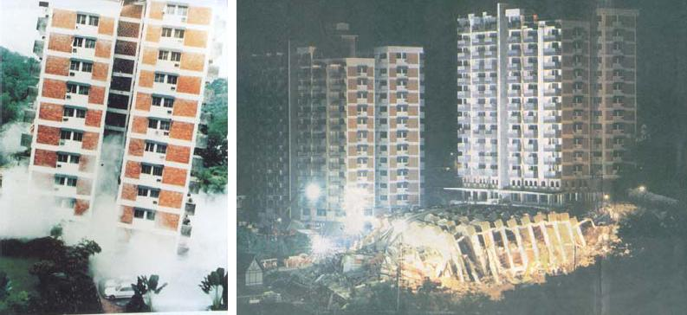
Countries that have mountainous or hill terrains suffer more frequent accidents of construction resulting from slope construction. A country such as Malaysia is a good example of the same (Gue & Cheah, 2008). This research gives numerous examples of the cases of collateral damage and casualties resulting from accidents and failure of slope construction. One such good example is the notorious collapse of the Tower apartments of the Highland towers as depicted by the image above (Gue & Cheah, 2008). Slope terrains creates a complexity that is difficult to overcome in construction. Since the sites are located in unique areas, there is a need for specialized equipment to effectively function in the limited construction space. The cost of construction in such terrain is quite high. In many cases these terrain require a larger budget to cover the need to build up land or flatten the slope or when it requires enhanced drainage and sewage accessibility for the street at the ground levels. Additionally there is need for extra work in constructing at a slope terrain in comparison to the flat sites (Gue & Cheah, 2008).Adding retaining walls for increased stability and building up land to the standard of eight inches above the soil may require extra work input and also time to complete the construction project.
Slope stability analysis using numerical modelling.
Plaxis is a computer aided design software developed for functionality of analyzing, deformation, the flow of the geotechnical engineering and stability of the land used for numerous types of constructions (Fawaz et al., 2014). It is advanced having input procedures that give it the ability of enhanced output facilities providing a detailed computed result presentation. It enable users to work with the software only after a few hours of training. Plaxis is made in two version; the Plaxis 2D and the Plaxis 3D (Fawaz et al., 2014).
The Plaxis 2D is a powerful computer aided design software that is user friendly and has a finite package of applications that are aimed to give a two dimensional analysis of construction ground stability and deformation. Not only is it used in civil engineering (construction) but also in rock mechanics and geotechnical engineering (Fawaz et al., 2014). It utilizes the predefined elements of the CAD like environment structure and loading types. In their paper Slope stability analysis using numerical modelling, Fawaz et al, (2014) emphasize that the safety analysis in Palxis can be done through Phi-C reduction where strength parameters of the soil (tan ɸ and C) are successively reduced till collapse (Fawaz et al., 2014). .
$\sum{Msf=\frac{\tan{φ (Input)}}{\tan{φ(Reduced)}}=\frac{C (Input)}{C (Reduced)}}$
Fawaz et al, (2014) give different profiles of the slope initially, after seismic load activation and after the influence of excavation. Example given blow is that of Plaxis 2d profile of a slope after excavation and after displacement of µ=2cm (Fawaz et al., 2014)..
Plaxis 2D Slope profile after maximum displacement of µ=2cm (Fawaz et al., 2014).
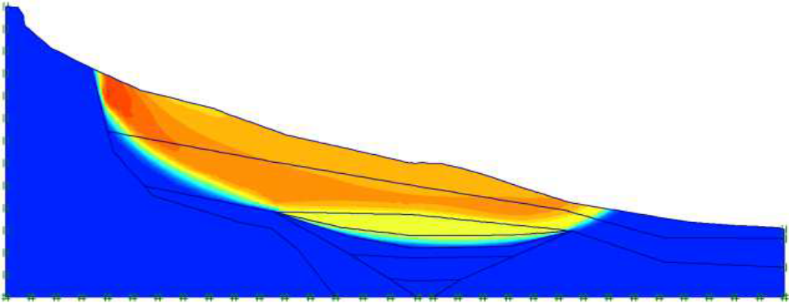
Plaxis 2D Slope Profile after excavation (Fawaz et al., 2014).
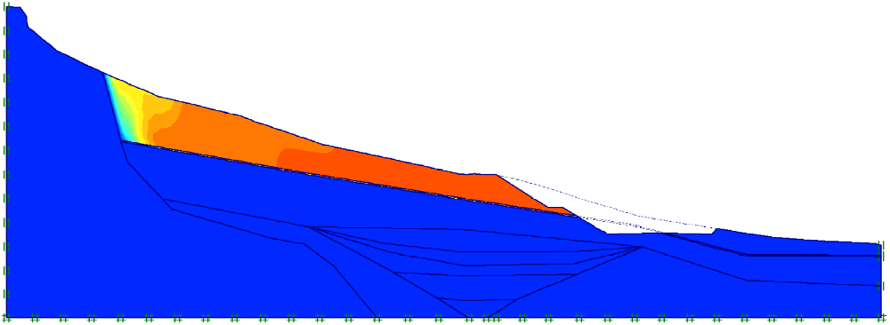

The key benefits of the Plaxis 2D is the efficient, fast and finite model creation, versatile and powerful post processing and realistic assessment of displacements and stresses. The user friendly software guides the users on creation of effective models with regard to data input and the geotechnical workflow. Users of the Plaxis 2D can define the geological cross sections and the complex structures of soils. In the structural mode of the software can define structural elements such as the geotextiles, anchors, piles, and prescribed loads and displacements. Users of the Plaxis 2D can model the construction process accurately (Fawaz et al., 2014).. This is done through deactivating and activating structural elements and sol clusters in each of the phases of calculation different stages of construction. A wide variety of challenges can be tackled with the consolidation plastic and safety calculation types where constitutive models vary from linear simple to non-linear and highly advanced models that enable simulation of rock and soil behavior. The versatile output offers the users different ways of displaying the displacements, forces, iso-surface plots and flow of data vector. The cross-sectional analysis tools allow for the detailed analysis of the output results. The curve manager allows for the creation of graphs through plotting various results type from the available data input.
Two Dimensional Slope Stability Analysis by Plaxis 2D.
Two Dimensional Slope Stability Analysis by Plaxis 2D exert that the analysis and the design of the slopes to be used for construction requires an in-depth comprehension of the failure mechanism that the slope is exposed in effort to employ the right stability analysis and design for construction (Chakrabarti, & Shivananda, 2017). The angle of friction value, the cohesion of the slope and the stability of a slope are directly proportional. The higher the cohesion of the slope and the higher the angle of friction, the higher the stability the slope apparent in preliminary aspects. For slope analysis and design the Limit equilibrium method is widely utilized. Despite not considering the stress and strain relation of the soil of a slope, the method can provide estimations of the factors that are necessary for the safety design of the slope for construction without the knowledge of the initial conditions therefore being highly favor by many engineers. An example is given of the slope analysis and design for homogenous soil using 2D. They make comparative analyses of the purely cohesive soil, purely C-ɸ soil and purely cohesion less soil (Chakrabarti, & Shivananda, 2017).
Cohesive soil
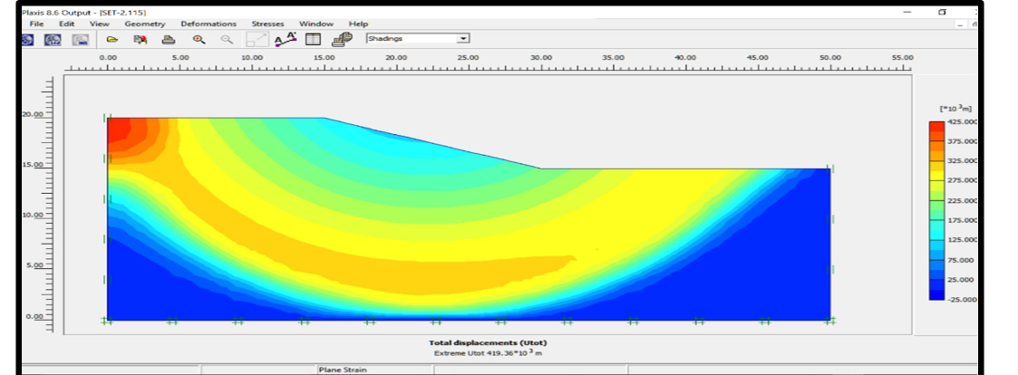
Whenever the cohesion values are variable then the value of the friction angle is ɸ=0 despite variance of the C-Value. The slope above for example was derived from the comparison of data sets (C-Value of 20, 40 and ɸ- Value of 0, 0).
Purely C- ɸ soil
Given a constant variation of the cohesion values such as C-value =5 then the ɸ- value varies with twice C-value (Chakrabarti & Shivananda, 2017).
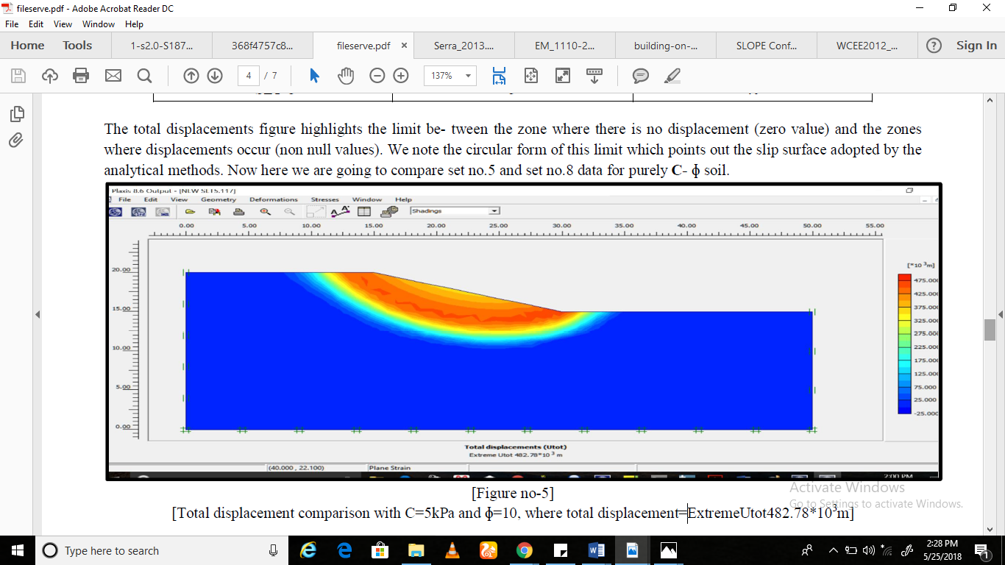
Cohesion less soil
The constant cohesive value with the variable value of angle of friction for purely C-ɸ soil, the ɸ-value is inversely proportional to the total displacement (Chakrabarti, & Shivananda, 2017).
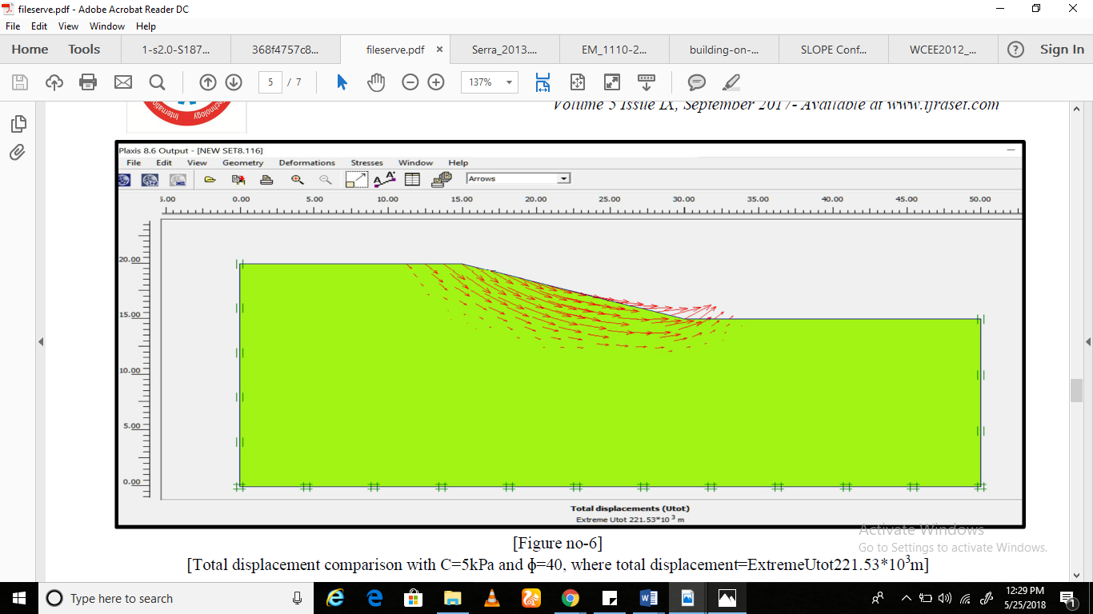
Conclusion
Construction on slopes can offer many advantages including amazing mountain side or hill side views, suitable fortress site and privacy. However slope terrains creates a complexity that is difficult to overcome in construction. Since the sites are located in unique areas, there is a need for specialized equipment to effectively function in the limited construction space. The cost of construction in such terrain is quite high. These failures are catastrophic and spectacular causing public nuisance and significant damage involving considerable number of fatalities. Ranging from landslides covering the roads on slopes to buildings and functional constructions on slopes toppling over. To overcome such risks and challenges, software’s such as Plaxis 2D have been developed to analysis the stability construction cites on sloes and correct designs. It has a wide variation of application ranging from foundations, embankment, excavation, mining tunneling to reservoir geomechanics. Plaxis is equipped with a wide range of features that have been advanced to model the diverse geotechnical problems within a single integrated software. Plaxis 2D helps in analysis and design of slope terrain while construction to avert any possible disasters that may come as a result of the construction project.

References
Chakrabarti, B., & Shivananda, D. (2017). Two-Dimensional Slope Stability Analysis by Plaxis-2d [Ebook] (5th ed.). International Journal for Research in Applied Science & Engineering Technology (IJRASET).
Engineers, U. A. C. O. (1902). Engineering and design manual–slope stability. Engineer Manual EM, 1110-2.
Fawaz, A., Farah, E., & Hagechehade, F. (2014). Slope stability analysis using numerical modelling. American Journal of Civil Engineering, 2(3), 60-67.
Gue, S. S., & Cheah, S. W. (2008, May). Geotechnical challenges in slope engineering of infrastructures. In international conference on infrastructure development, Putrajaya.
Wahed, S. (2007). Slope Construction and Maintenance Practices [Ebook]. Jurutera Perunding GEA (M) Sdn Bhd.

